JMeter Performance Testing Report Template

Project Overview
Project Name: Genesis Technology
Module/Feature: Home, Services (5 module), Projects(6module), Client, Blog,About.
Tested By: Refat Tamanna Ringky
Environment: JMeter
Date of Test Execution: 22-01-26
JMeter Version: Apache JMter 5.6.3
Test Type: Performance

2. Test Objectives
- Validate application performance under expected load
- Measure response times, throughput, and error rate
- Identify bottlenecks or performance degradation
- Validate system stability and scalability

3. Test Scenario

Description of Scenario:
Test Scripts Used:
Protocol: (HTTP / HTTPS / REST / SOAP / JDBC / FTP)

4. Test Data

Parameter | Value
Virtual Users | 5
Ramp-up Time | 2s
Duration | 2.46min
Loop Count | 2
Think Time | 2000-3000ms

5. Listener Reports

5.1 Aggregate Report
Metric | Value
Samples | 70
Average Response Time (ms) | 3534
Min Time (ms) | 264
Max Time (ms) | 19522
90% Line (ms) | 7731
95% Line (ms) | 8351
99% Line (ms) | 16170
Throughput (req/sec) | 37.1/min
Error % | 0.00%

5.2 Summary Report
Label | # Samples | Average | Min | Max | Std Dev | Error % | Throughput | Received KB/sec | Sent KB/sec
HTTP Request-Home | 10 | 489 | 171 | 1487 | 409.31 | 0.00% | 4.6% | 0.09 | 0.02
HTTP Request-Client | 10 | 493 | 177 | 2253 | 621.03 | 0.00% | 4.5% | 0.09 | 0.02

5.3 View Results Tree (Sample Analysis)
- Pass/Fail summary
- Request details
- Response assertions
- Error stack traces (if any)

Attach screenshot if needed.
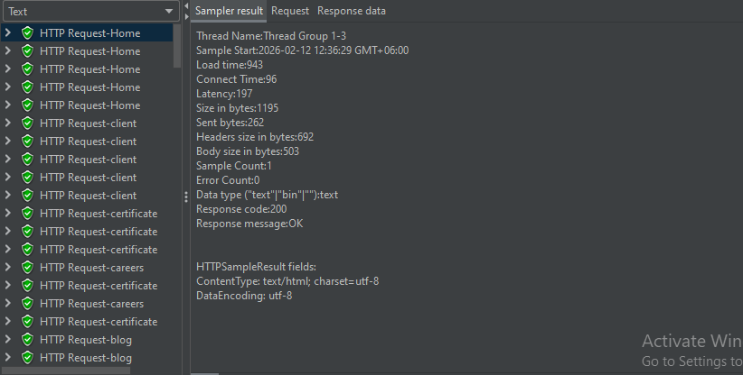

5.4 Response Time Graph
- Overall response time trend
- Peak load periods
- Observed spikes
(Attach graph screenshot)
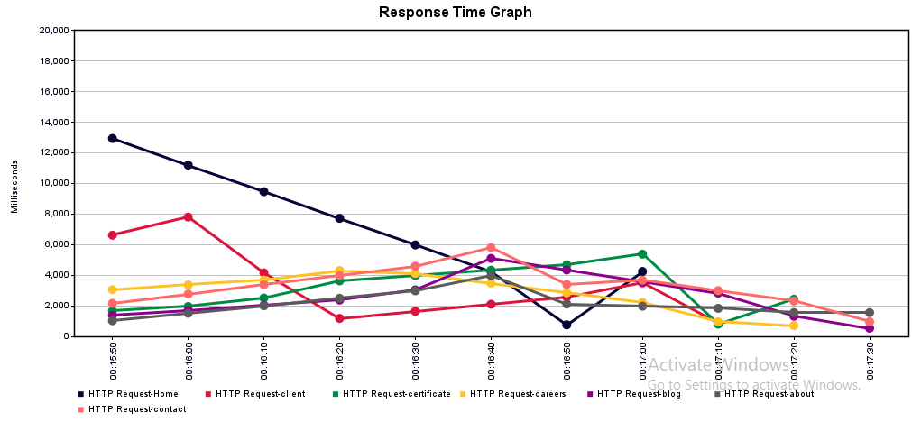

5.5 Throughput & Hits per Second
- Requests per second-27.6/sec
- Server capacity behavior
(Attach listener graph)

6. Assertion Report

6.1 Assertion Types
- Response Code Assertion
- Response Data Assertion
- JSON/HTML Assertion
- Duration Assertion
- Size Assertion

6.2 Assertion Results
Sample Name | Assertion Type | Rule Used | Pass/Fail | Error Message

7. Recording Report (HTTP(S) Test Script Recorder)

7.1 Recording Summary
- Recorded endpoints
- Total transactions
- Dynamic parameters identified
- Correlation applied
- Parameterization details

8. System Resource Monitoring
(If Server Monitoring Plugin or Grafana used)

8.1 CPU Usage
- Average CPU
- Peak CPU
- Graph Screenshot

8.2 Memory Usage
- Heap / Non-Heap
- Peak Memory

8.3 Disk I/O
- Read/Write operations

8.4 Network Usage
- Inbound / Outbound traffic

9. Error Analysis
- Failed request count
- HTTP status codes
- Timeout issues
- Server errors (5xx)
- Client errors (4xx)
- Assertion failures
Error Type | Count | Possible Cause

10. Bottlenecks Identified
- Slow API endpoints
- Memory leakage
- High CPU bottleneck
- DB query performance issue
- Network latency issues

11. Recommendations
- Optimize affected APIs
- Add caching mechanism
- Increase server concurrency
- Indexing optimization for database
- CDN or load balancer improvements

